Layout Project By Xiuyuan Liu

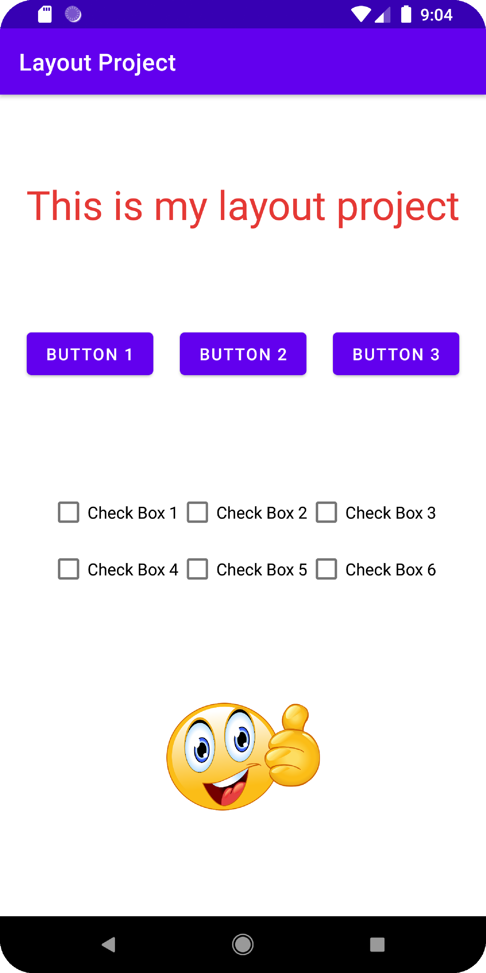

Figure1. Starting Screen

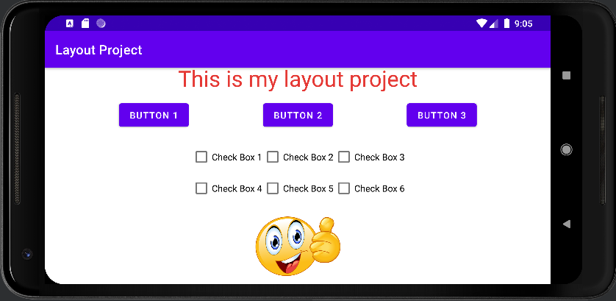

Figure 2. Landscape View

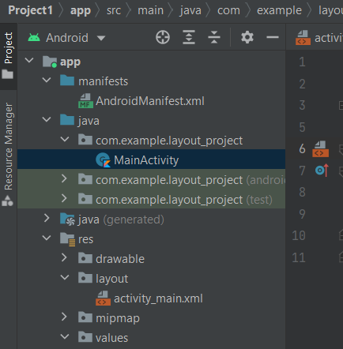

Figure 3. Class of the Layout Project

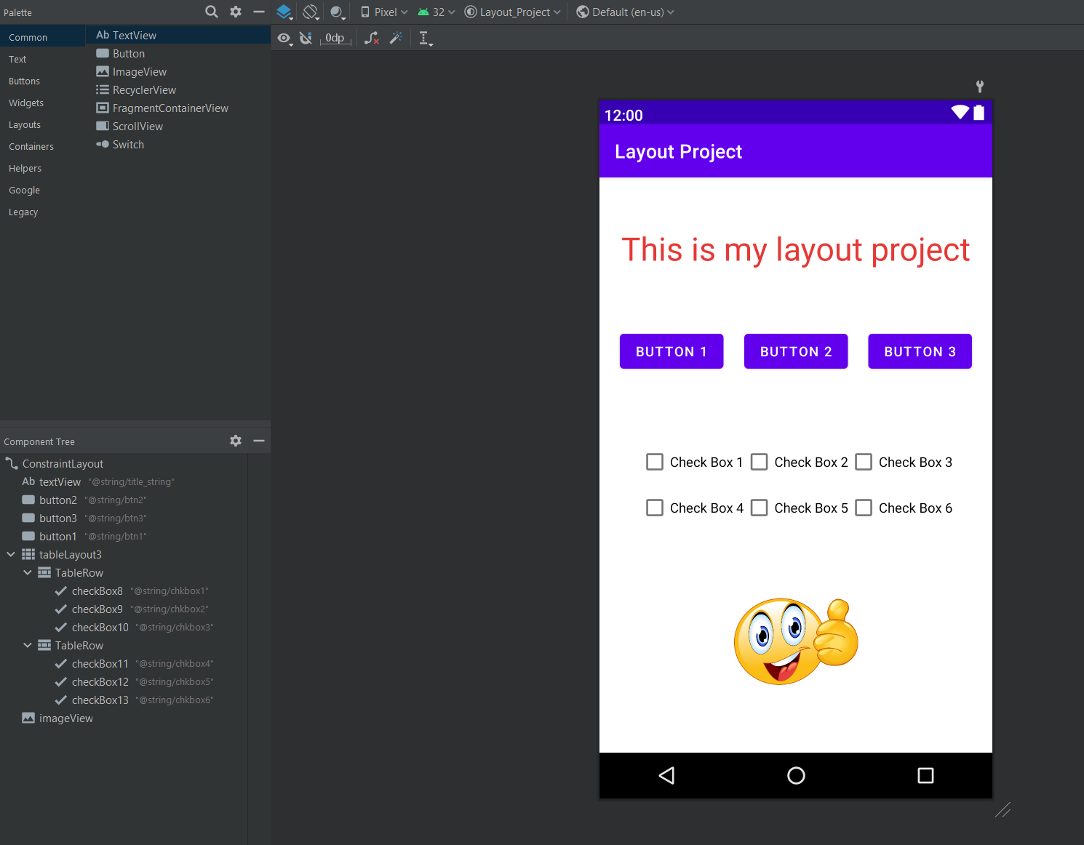

Figure 4. No Errors in Layout